MEC

Mathematical Expression Calculator

# User’s Guide

# 

**Table of contents** Introduction.................................................................................................................................... 3 Abbreviations ................................................................................................................................ 3 Prerequisites ................................................................................................................................. 4 Getting started............................................................................................................................... 5-7 Valid Input………………………………………………......................................................................................... 8 Examples……………………………………………….......................................................................................... 9-11

**INTRODUCTION**

**This document describes software examples for the MEC program. It also describes the necessary hardware and software to run the examples.**

**Page 4 of this document describes necessary prerequisites and how to get started with the code examples. Page 4 describes how to run each of the application examples.**

**ABBREVIATIONS**

**MEC - Mathematical Expression Calculator**

**E - Evaluate another expression with the same variable values**

**S - Start over**

**Q - Terminate program**

**PREREQUISITES**

**To successfully run the software described in this document, the following is needed:**

* **An IDE that compiles/runs Java code**
* **JDK**
* **Beanshell Java source interpreter (bsh-2.0b4.jar)**

**GETTING STARTED**

**Here are instructions on how to get started and start using this small application.**

1. **Open the IDE that compiles/runs Java code. We will be using Netbeans 8.0.2 for demonstration purposes.**
2. **Once in Netbeans, click File and Open up our project, called goCalculator.**
3. **The project goCalculator should already contain the bsh-2.0b4.jar and JDK 1.8, inside the ‘Libraries folder’. To make sure, they are in there, click on the side bar of Netbeans that says ‘Projects’. Here you will see our project name, goCalculator. Click on the ‘+’ to expand. Next you should see that ‘Source Packages’ and ‘Libraries’ have appeared. Click on the ‘+’ that is next to ‘Libraries’ to expand this folder. Now you should check that the two files mentioned above are there, otherwise this program will not work! You can download both of these files from their website.**

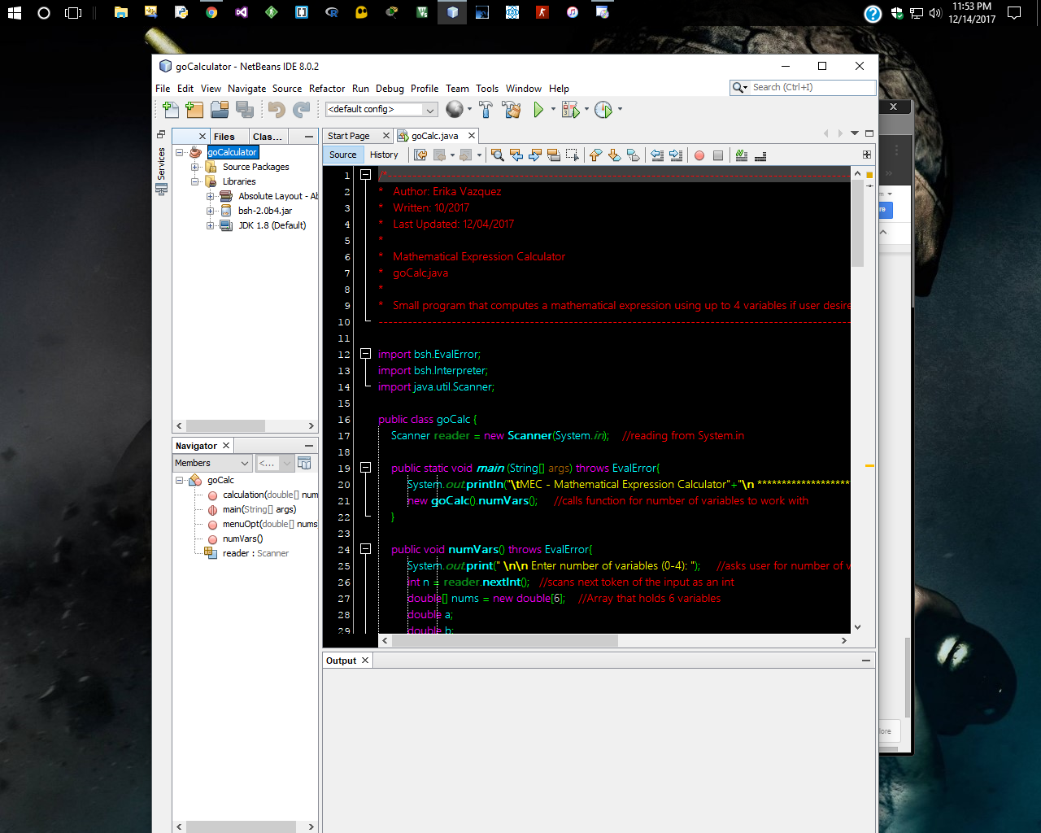

**4. Once the steps above are completed, you should see the code, and will look something like the picture below.**

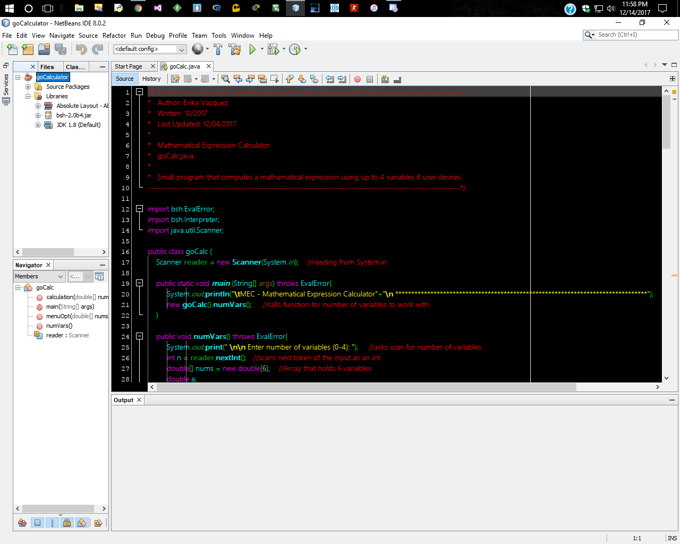

**5. To run this program, just click on the green play button. The output window will appear and you will be prompted on what to do next in that window. If steps above are not done or missing a file, then you will receive an error.**

**ACCEPTABLE VALUES/CHARACTERS**

* **This calculator evaluates math expressions. Integers, negative numbers, and decimals are all valid.**
* **This is a calculator that can work with up to 4 variables (a, b, c, and d ONLY).**
* **No spaces allowed**
* **No equal signs =**
* **For multiplication use star sign \***
* **For division use slash /**
* **For addition use +**
* **For subtraction use -**
* **For modulus use %**
* **This calculator evaluates math expressions as PMDAS, meaning anything inside parentheses will be evaluated first, then Multiplication/Division, and then Addition/subtraction.**

**\*\*This app uses beanshell, which is a really helpful interpreter for math expressions. Users may work with numeric operations that class Math in java performs, such as the elementary exponential, logarithm, square root, and trigonometric functions. For example,**

* **Users can work with exponents by using Math.pow(x,y)**
* **Users can work with square root by using Math.sqrt(x)**

**APPLICATION EXAMPLES**

**EXAMPLE 1: Calculating 58×5+2 (No variables)**

1. The program starts by prompting user to enter the number of variables to use. Type in 0 for this example, then press ENTER key.
2. Type the expression as follows(**no spaces or equal signs allowed, refer to page above to see acceptable format/math operators/valid input**) **58*5+2**
3. hit ENTER
4. Results are displayed. Program will prompt user to type an option.

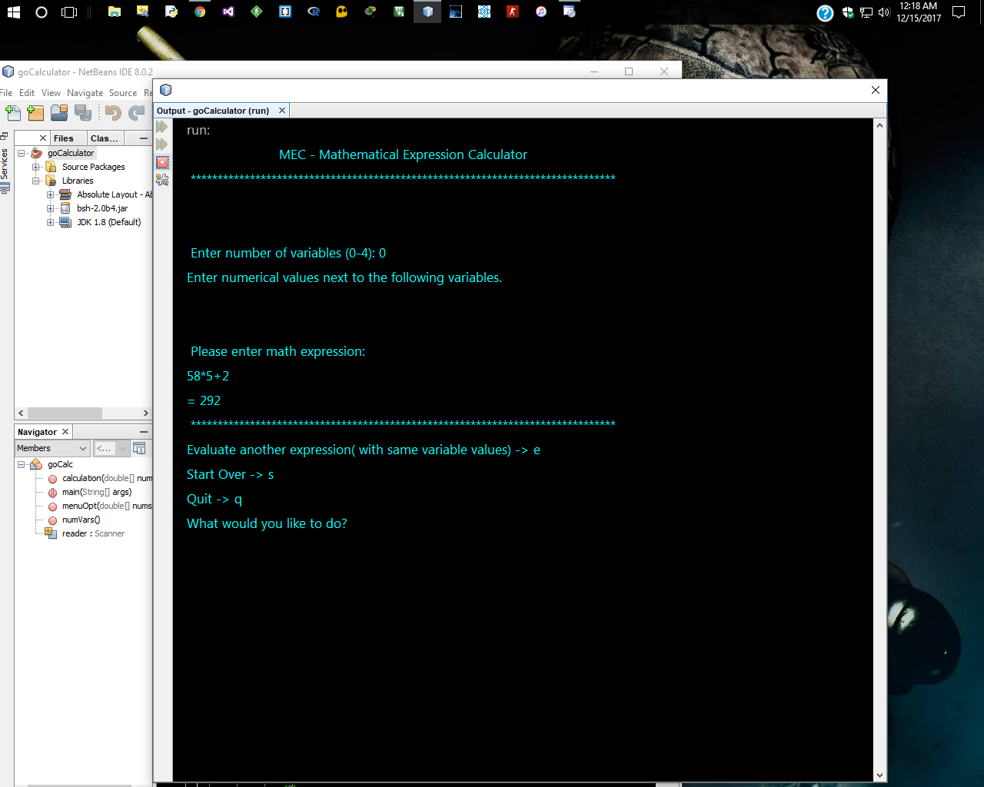

**EXAMPLE 2: Calculating a-b+c×d when a=10, b=2, c=4, d=12**

1. The program starts by prompting user to enter the number of variables to use. Type in 4 for this example, then press ENTER key.
2. Next to a: type **10**, next to b: type **2**, next to c: type **4**, next to d: type **12**
3. Hit ENTER key
4. Type the expression as follows(**no spaces or equal signs allowed, refer to page above to see acceptable format/math operators/valid input**) **a-b+c*d**
5. hit ENTER key
6. Results are displayed. Program will prompt user to type an option.

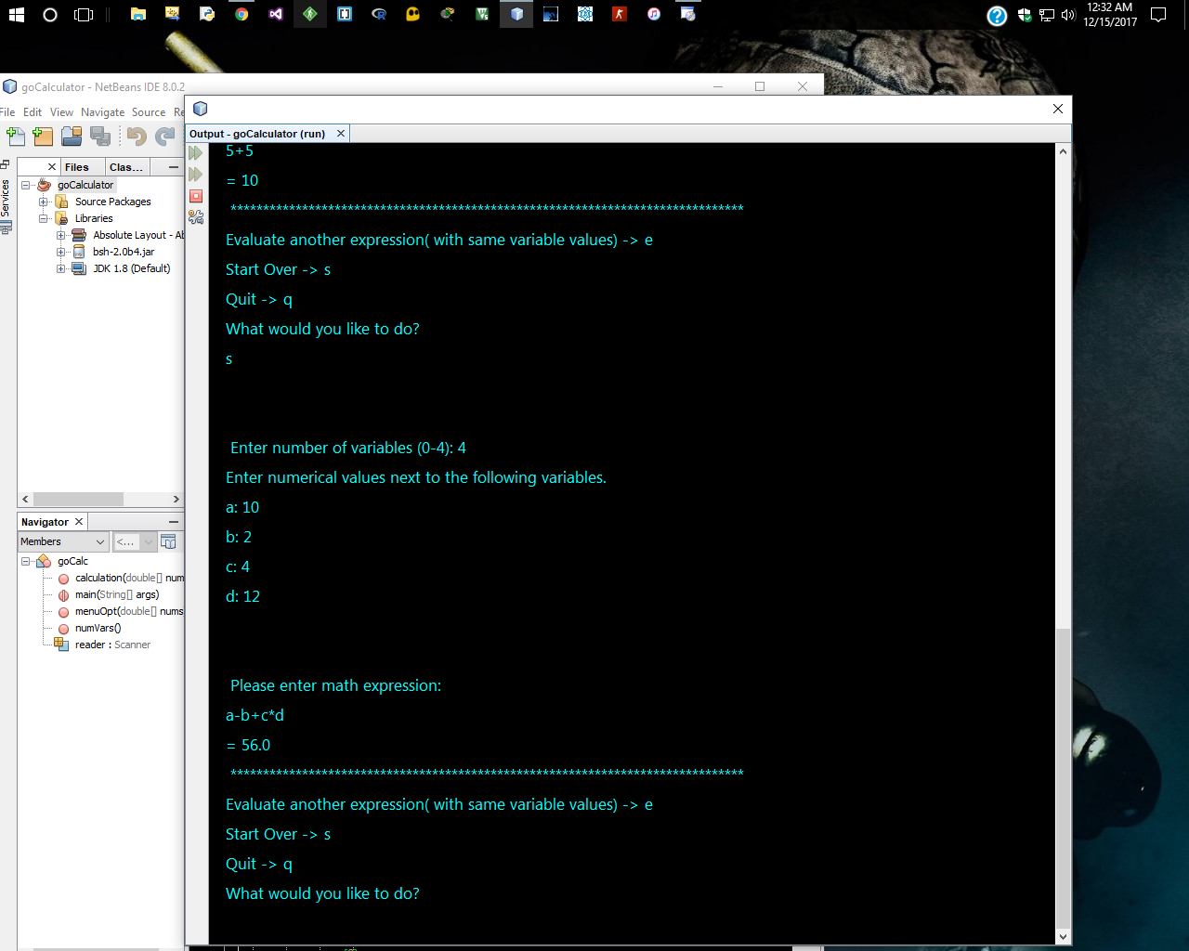

**EXAMPLE 2: Calculating (a-b+c)×d when a=10, b=2, c=4, d=12**

**\*\*Expressions in parentheses are evaluated first. In general, multiplication and/or division are evaluated before addition and/or subtraction.**

1. The program starts by prompting user to enter the number of variables to use. Type in 4 for this example, then press ENTER key.
2. Next to a: type **10**, next to b: type **2**, next to c: type **4**, next to d: type **12**
3. Hit ENTER key
4. Type the expression as follows(**no spaces or equal signs allowed, refer to page above to see acceptable format/math operators/valid input**) (**a-b+c)*d**
5. hit ENTER key
6. Results are displayed. Program will prompt user to type an option.

